

NATIONAL UNIVERSITY OF COMPUTER AND EMERGING SCIENCES

(KARACHI CAMPUS)

Department of Computer Science

Fall 2020

**EE-229 Computer Organization**

**& Assembly Language**

**Project Report**

Project Name: **IQ Quiz Generator**

Group Members:

* DARPAN KUMAR (Group Leader) - [19K-1309]
* VINAY KUMAR - [19K-1320]
* RITIK - [19K-0199]

**Abstract:**

This program is developed in other programing languages, our purpose of selecting this project was to try that program and develop it in assembly language. Our plan is to generate a question paper is to analyze a person’s IQ by providing him rounds of questions five in each round. The winning criteria is to answer questions with proper inputs then to check if the majority answers are correct to move on to the next round. In figuring out the IQ, we would calculate the overall correct answers to the questions attempted. We would store the IQ score with name of the candidate to calculate and modify the average IQ of everyone who took that quiz. For tools we will be using visual studio community for making this project.

**System Diagram:**

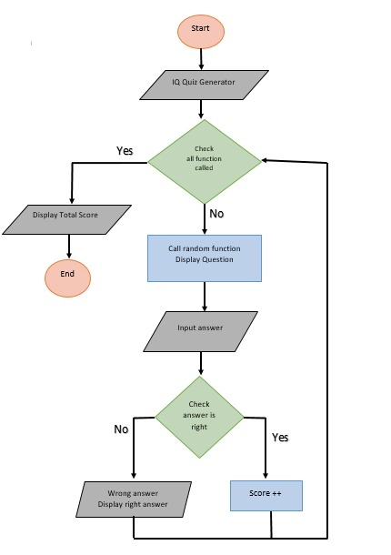

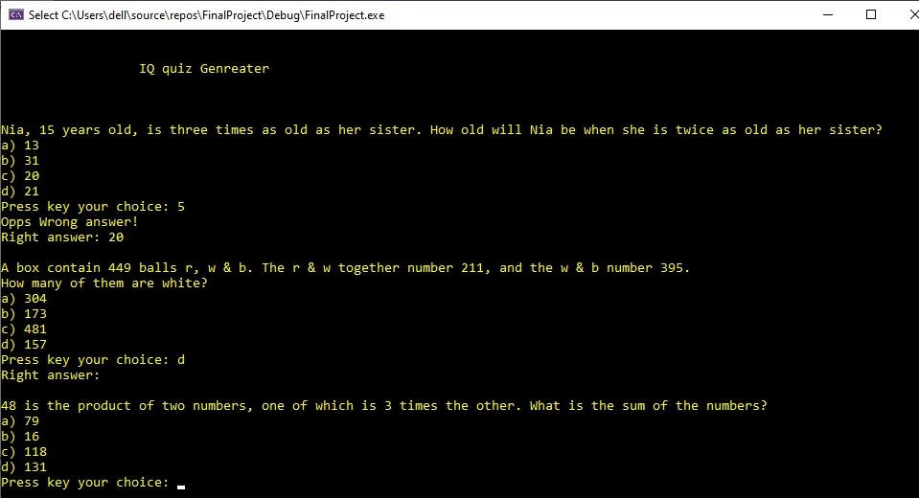**Console Snippets:**

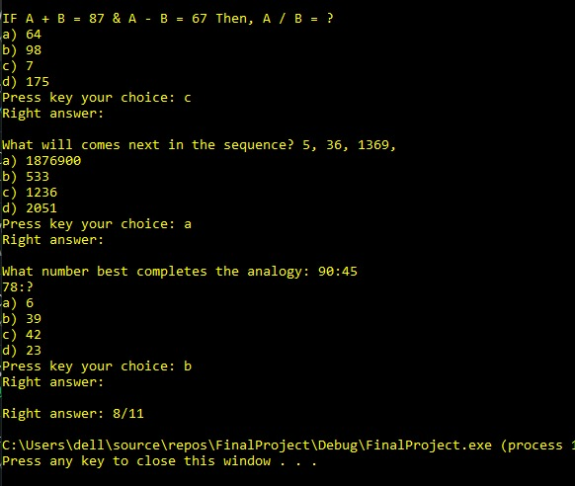

**Tools Used:**

* Visual Studio Community 2019

**Contributions:**

**Darpan Kumar (Leader):**

* 4 procedures (fun #1-4) and overall management.

**Vinay Kumar:**

* 4 procedures (fun #5-8).

**Ritik:**

* 4 procedures (fun #9-12).

The End